Defining System Scope

The model built in this step defines the scope of the system. The conceptual or scoping model defines the boundaries of the system (i.e., what is in scope and what is out of scope). It identifies:

 The events outside the system that cause the system to react,

 The actors outside the system that interact with the system,

 The information that flows between the system and the actors outside the system,

 The major functions included in the system,

 The user population.

The System Concept Proposal –as per ff- Includes a:

 Statement of Purpose 

 Context Diagram 

 Event List – For coming, ff -

 ... – For coming, ff -

Statement of Purpose
[ To justify any IT investment it is important to provide a concise statement of the purpose. IT investments may be undertaken to replace or supplement current business processes (e.g. providing computers for new staff to support a current process, introducing workflow software to enhance staff productivity), or they may be used to provide entirely new services. The project may involve the establishment or improvement of internal or interagency transactions, or it may facilitate business between the State and external agencies or private citizens. This statement is the most important basis for evaluating and prioritizing your budget request.

The purpose statement should be evaluated to ensure that it is in alignment with the stated charter or mission of your division. How does this IT investment align with or support your division's goals and objectives

An example !!: Statement of purpose for a new application is given below:

"The purpose of the Marcos’s project is to develop and implement an application system to provide citizens of DN with web-based access to timely multimedia data about pollution discharge facilities and online permit application and monitoring services, using a flexible query and reporting capability and easy-to-use "wizards"." ]

Context Diagrams
A context diagram shows the software system and the world around the system. In this big picture view, the system is treated as a closed box. In essence, the goal of the development process is to both fill and fulfill the box. The emphasis is on how the system relates to the world, not on its architecture or any other form of decomposition.
Context diagrams have been around in one form or another for three decades and have been presented in various forms. Historically they were often shown as dataflow diagrams (DFDs), which follows naturally from their use in structured analysis methods that make heavy use DFDs as formalism. In object-oriented modeling the appropriate style is to express the system and the world around it as objects connected by associations. Michael Jackson has taken the concept of context diagrams further and used them as the basis for understanding problem frames.

In UML, the simplest presentation of a context diagram shows the system as a box surrounded by its associated actors. The associations between actors and the system and between other actors are undirected, i.e. there are no arrows. The association is mutual and there is no notion of "flow." Notationally, such a diagram is a use case diagram without the use cases -- a "use-case-less" diagram. And although it's useful and legitimate UML, it is not a formal diagram type in UML.

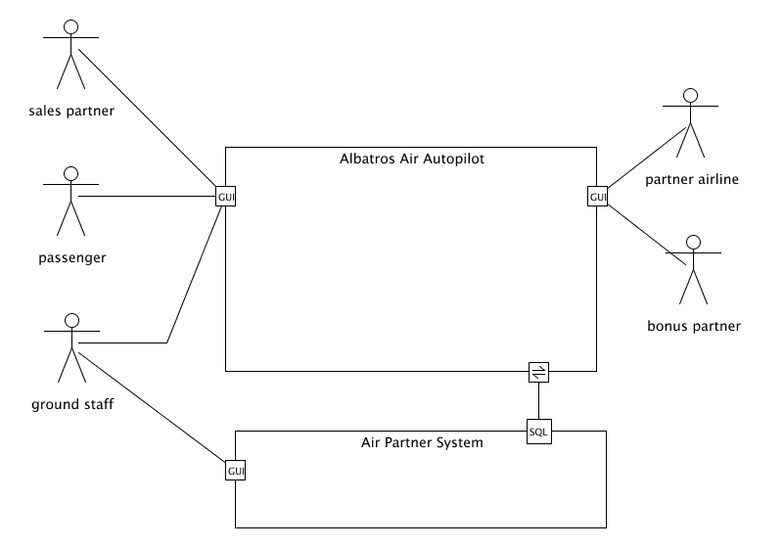
Figure 1
http://www.itmeyer.at/umlet/uml2/ContextCompositeDiagram.html
Context diagrams are intentionally simple with a clear responsibility: They clarify where in the world a system fits, offering an opportunity to discuss the roles that use it and are used by it. It should be possible to fit a context diagram plus a brief description of each external role on a single page.

Using Context Diagrams
Use-case diagrams are very powerful, but in most systems, the number of use cases you have will be larger than you can conveniently show on one diagram. A popular form of the use-case diagram may help summarize the interaction of actors with the system. This diagram is called a top-level use-case diagram, but as it’s very similar to a type of diagram that predates UML; often you’ll see it called by its traditional name: context diagram. This type of diagram, shown in Figure 8-7, displays the system of interest and all its actors—but it hides the use cases themselves.
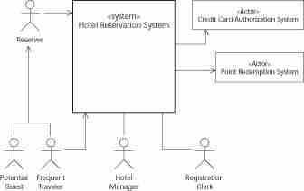

Figure 2, System context diagram.
When you draw these context diagrams, you don’t have to worry about the arrows. If an actor is always the initiator in all its use cases, you can have the arrow pointing to the system. If an actor is never the initiator, you can have the system pointing to the actor.
You can draw these context diagrams right after you identify the actors—and before you take a crack at the use cases—so a good guess is probably sufficient. To be safe, don’t use the arrowheads if you’re not sure.
As with the regular use-case diagrams, context diagrams can be subdivided into levels. To minimize confusion, focus your diagram on the subsystem, component, or class of interest—and use stereotypes to indicate what the diagram elements are doing.
From:
http://codeidol.com/other/uml/Introducing-Use-Case-Diagrams/Using-Context-Diagrams/

Use a Context Diagram to help define the scope of a project, assess potential project benefits and risk factors.

Typically, a Context Diagram contains a logical business process and physical data flows.
Sorry, Please make one like this and after convert to one like figure 1 or figure 2. Include all as an attachment in your System Concept Proposal

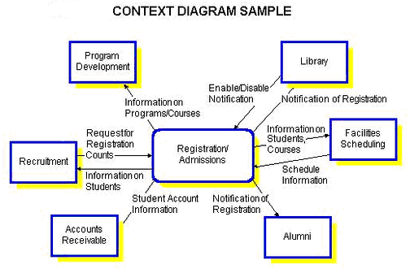

It illustrates the business system, not the computer system. It shows the input and output data flows to a central process that represents the business system under analysis. The context diagram defines the scope of the project.

Project Scope

A Context Diagram confines project scope to an agreed limit by obtaining agreement from the customer on the data flows that are included in the scope of a project. The Context Diagram focuses on relationships with external entities and identifies the information that is exchanged between these external entities and the business system under review. The external entities themselves are outside the scope of the project but the data flows between the entities and the business system are within the project scope.

Components of a Project Level Context Diagram

A Project Level Context Diagram consists of:

- external entities,
- central process,
- data flows.

External Entities

External entities are also known as terminators, sources/sinks, and actors. External entities define the sources and destinations of information entering and leaving the system. An external entity can be a person, system, or organization that has pre-defined behaviour.

An external entity is outside the domain, or context, of the business area that is under analysis.

Justify the presence of each external entity and describe the role each plays in the scope of the project. Describe the inputs and outputs to and from each external entity.

Central Process

The central or parent process represents the business system that is the target of analysis. It is the highest level process that receives inputs of data from external entities and transforms that data into outputs to the external entities. Provide a brief description (i.e., one page or less) of the central process outlining at a high level the major functionality of the business system under review.

Data Flows

Data flows are the pipelines through which data are transmitted between the external entities and the business processes. They represent the information that flows between the two.

A data flow is also called a data flow vector.

Examples of data flows are: purchase order, customer profile, sales report, product.

Naming Data Flows

A data flow is given a name, which describes the content of the data being transmitted, and a description. For example:

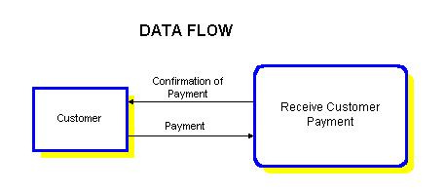
Data Flow Name: Payment
Description: Payments made by customer for goods received.

Steps to Constructing a Context Diagram

 Identify the external entities that exchange information with the business system that is the target of analysis.

Note: If an organizational Context Diagram exists (from systems planning), extract the external entities and data flows used by the business system under review from the organizational Context Diagram.

 Identify the data flows to and from each external entity.

 Draw a process box at the center of the diagram to represent the highest level business process that will exchange information with the external entities. See above “Context Diagram Example”.

